**Car Features Analysis**

**Objective:**

The goal of this project is to identify the most popular features and categories among consumers and determine which ones are most profitable for the manufacturer. The primary aim is to assist a car manufacturer in optimizing pricing and product development decisions to maximize profitability while meeting customer demands.

**Approach:**

**Data Collection**

* Configured the Kaggle API by placing kaggle.json in the .kaggle/ directory.
* Downloaded the dataset using the command kaggle datasets download -d CooperUnion/cardataset.

**Data Cleaning & Preprocessing**

* Imported necessary libraries and addressed missing values, duplicates, and inconsistencies.
* Executed data transformation and detected outliers.
* Standardized data formats to maintain consistency for analysis.

**Data Analysis & Visualization**

* Performed exploratory data analysis (EDA) using Excel.
* Generated statistical summaries and conducted trend analysis.
* Created various charts and graphs (scatter plots, histograms, regression analysis) to reveal key insights.

**Dashboard & Reporting**

* Developed an interactive dashboard using Tableau, featuring key performance indicators (KPIs).
* Integrated slicers and filters to enable dynamic data exploration.

**Documentation**

* Recorded project objectives, methodology, findings, and insights.
* Included visual representations, observations, and actionable recommendations.

**Tools & Technologies Used:**

* **Python (Pandas)** – Used for data cleaning and preprocessing.
* **Jupyter Notebook** – A code editor for writing and executing scripts.
* **Microsoft Excel** – Utilized for data analysis, pivot tables, and visualization.
* **Tableau** – A data visualization tool for dashboard creation and insights generation.
* **Microsoft Word** – Used for project documentation.
* **Kaggle API** – Facilitates dataset retrieval from Kaggle.



**Business Problems Addressed:**

1. **Popularity of Car Models Across Market Categories**

|  |
| --- |
| * Used Countif and Averageif to show the number of cars in each market category and their corresponding popularity scores. |
| * Created Combo chart to visualize the relationship between market category and popularity. |
| * **Findings:** * Sedan and SUVs have a significantly higher number of models as compared to others. * The number of available models does not always correlate with its popularity. |
|  |
|  |

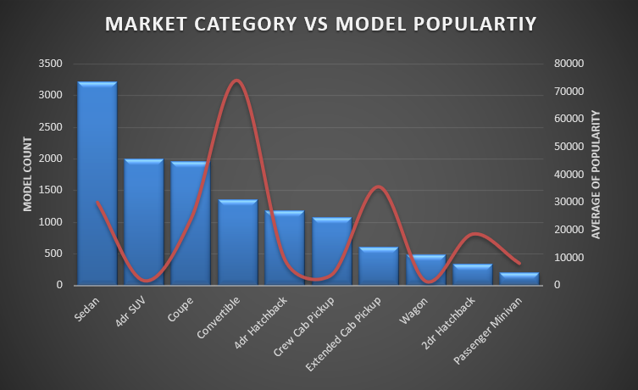

1. **Relationship Between Engine Power and Price**

|  |
| --- |
| * Created Scatter Plot to show the relationship between a car's power and its price. |

* **Findings:**
* A positive correlation exists between engine power and price, indicating that higher-powered cars tend to be more expensive.

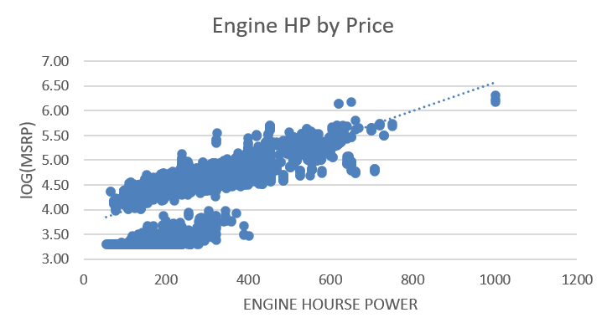

1. **Key Features Affecting Car Price**

|  |
| --- |
| * Performed Regression Analysis to identify the features that have the strongest relationship with a car's price. |
| * Created waterfall chart using correlation coefficients to identify the relationship between price and different car's feature. |
| * **Findings:** * Features such as engine power, brand reputation, and fuel efficiency strongly influence car prices. |
|  |

1. **Variation in Average Price Across Average Manufacturers**

|  |
| --- |
| * Created a pivot table that shows the average price of cars for each manufacturer. |
| * Create a line chart and added error bars to visualize the relationship between * manufacturer and average price. |
| * **Findings:** * BMW, Mercedes, Audi have the highest average prices. * Toyota, Honda, Ford have significantly lower average prices. |

1. **Relationship Between Fuel Efficiency and Cylinders**

|  |
| --- |
| * Created scatter plot and used correl function to show the relationship between fuel efficiency and the number of cylinders in a car's engine. |
| * **Findings**: * A negative correlation exists between the number of cylinders and highway MPG, meaning cars with more cylinders tend to have lower fuel efficiency. |
| * Number of cylinders between 4 to 6 shows the higher fuel efficiency (Savings) and 6-8 has higher fuel cost (Performance), after that it gradually decreases. |

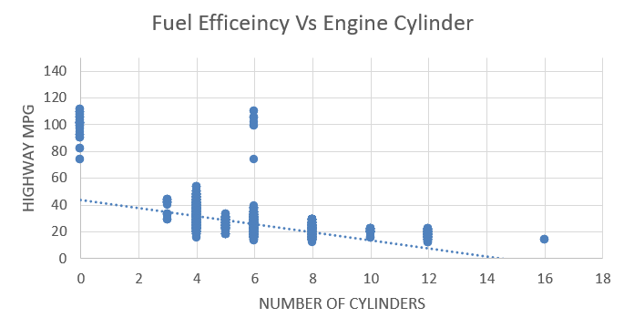

**Building the Dashboard**

Task 1: How does the distribution of car prices vary by brand and body style?

* Created a stacked bar chart to represent the distribution of total car prices by brand and body.
* The different colours represent the different market categories within each branch.
* **Findings:**
  + Bentley, Rolls-Royce, and Aston Martin have high MSRP despite selling the fewer units.
  + Ford, Toyota, Honda, Hyundai and Kia have a mid-range MSRP.

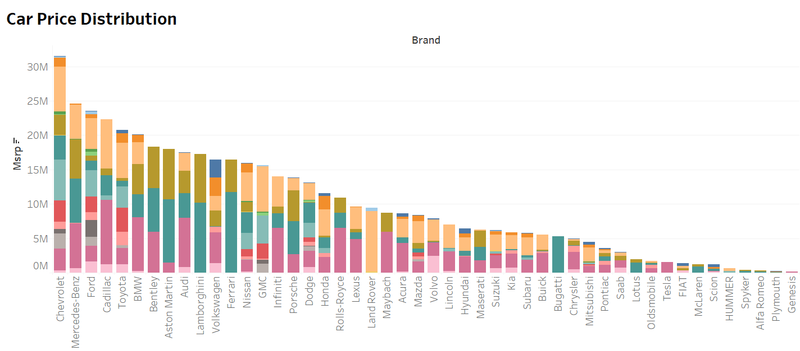

Task 2: Which car brands have the highest and lowest average MSRPs, and how does this vary by body style?

* Created a stacked bar chart to represent the distribution of average car prices by brand and body.
* The different colours represent the different market categories within each branch.
* **Findings:**
* Bugatti, Maybach, and Rolls-Royce have the highest average MSRP
* Plymouth, Suzuki, and Oldsmobile have the lowest average MSRP.

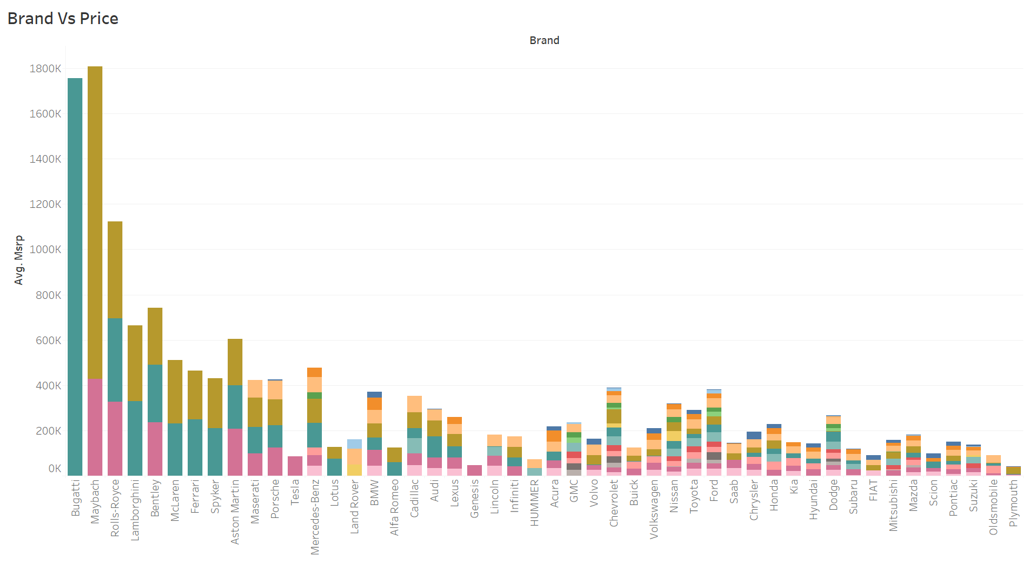

Task 3: How do the different feature such as transmission type affect the MSRP, and how does this vary by body style?

* Created Scatter plot to show the price distribution by body style of the cars.
* The different color represents the different transmission type of the cars.
* Findings:
* SUVs and Sedans have a mid-range pricing, suggesting high demand.
* Hatchbacks, Vans, and Minivans are the most affordable.

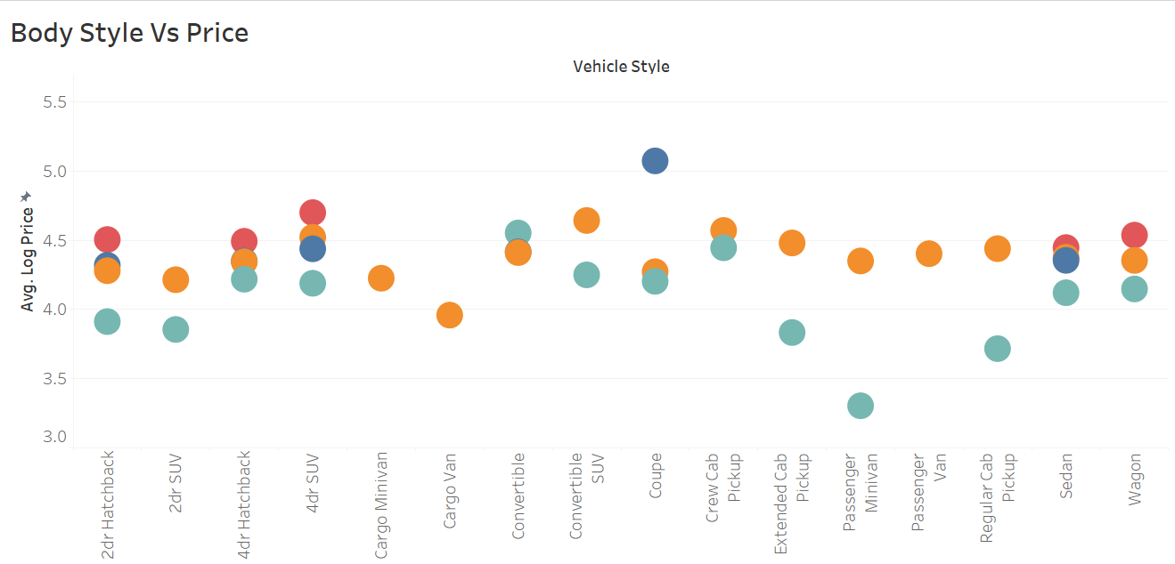

Task 4: How does the fuel efficiency of cars vary across different body styles and model years?

* Created a line chart to show the fuel efficiency of cars for different body styles.
* **Findings:**
* After 2000, there was a slow but steady increase in MSRP, suggesting advancements in hybrid and fuel-efficient vehicles.
* A significant spike in MSRP after 2014 indicates rise of electric vehicles (EVs) and hybrid technology.
* SUV and Sedan have relatively higher fuel efficiency than that of Coupe and Convertibles.

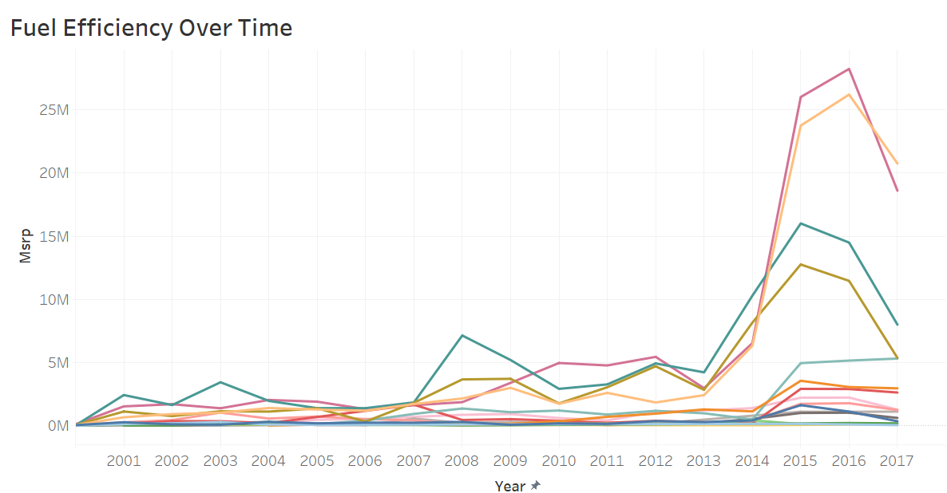

Task 5: How does the car's horsepower, MPG, and price vary across different Brands?

* Created a bubble chart to show the variation in car’s power , MPG and price across brands and model.
* **Findings**:
* Hybrid & Electric Models demonstrate superior city MPG while maintaining reasonable engine power.
* High-performance models trade fuel efficiency for higher horsepower.

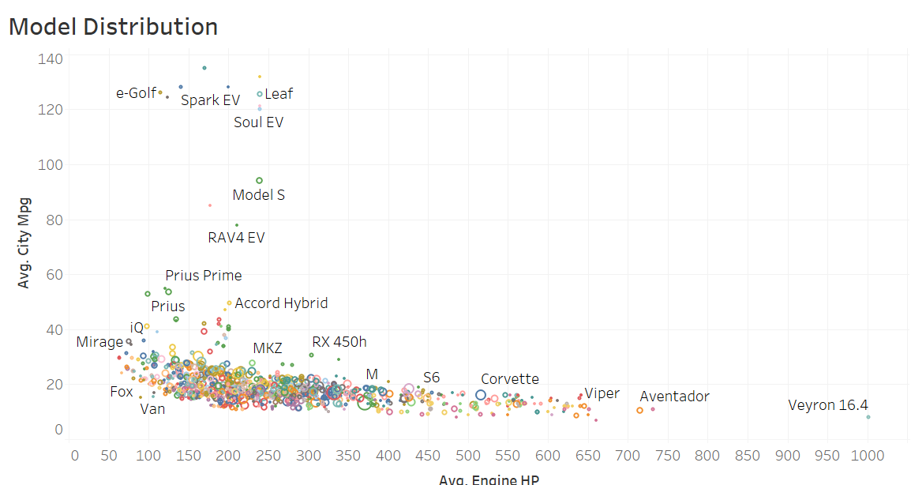

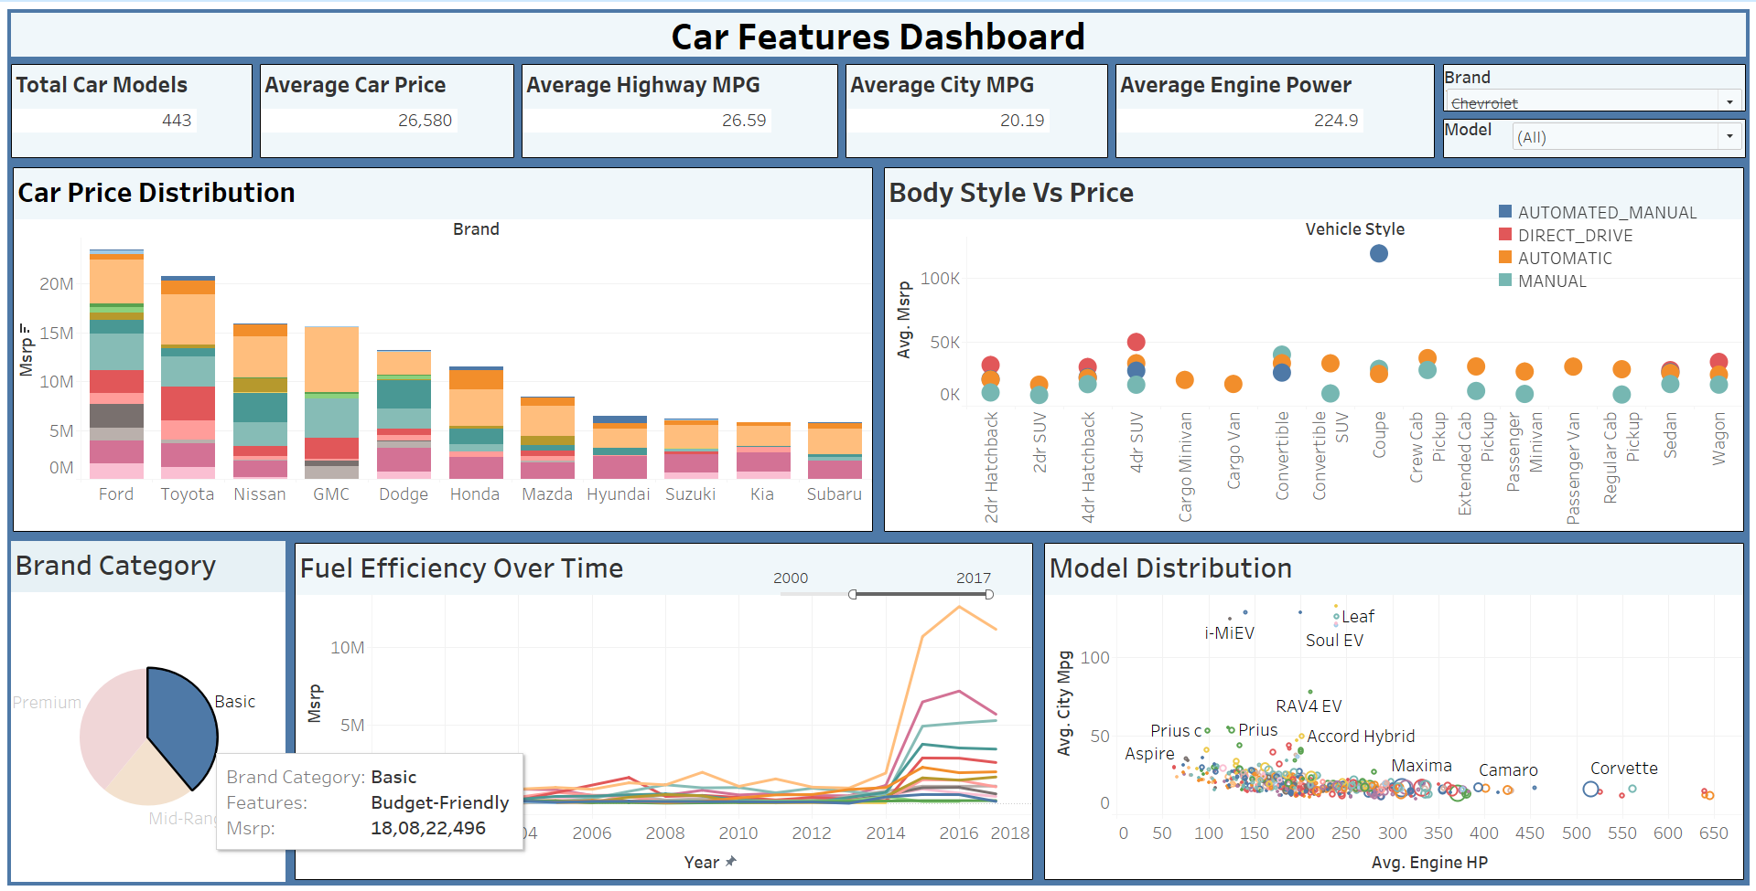

**Results & Insights:**

* Basic: Marti Suzuki, Hyundai and Kia focus on fuel efficiency and affordability
* Mid-Range: Honda and Toyota focus on balanced performance and efficiency.
* Premium: BMW and Audi focus on higher HP and premium features.
* Sedans and SUVs dominate the mass-market sales.
* Hatchbacks are priced lower, popular choices to budget friendly customers.
* Engine power, brand reputation, and fuel efficiency strongly impact price.
* Sharp increase post-2010 aligns with the rise of hybrid and electric vehicles (EVs),
* Higher horsepower correlates with lower MPG, especially in SUVs.
* Hybrid & Electric Modelsdemonstrate superior city MPG while maintaining reasonable engine power.

**Strategic Recommendations:**

1️. Market Strategy: Focus on High-Demand Segments

* Target SUVs & Sedans, as they dominate market demand.
* Focus on models with the highest return on investment (ROI).
* Offer multiple trims (basic to premium) to attract different customer segments.

2️. Pricing Optimization: Competitive Positioning

* Benchmark pricing against Toyota, Honda, Ford, Hyundai for strategic price positioning.
* Implement dynamic pricing based on demand, competition, and seasonal trends.

3️. Product Development: Body Style Optimization

* Invest in SUV & Sedan models to maximize revenue.
* Invest in hybrid & electric models to meet changing consumer demands.
* Retain hatchbacks in emerging markets due to affordability appeal.

4️. Transmission & Fuel Efficiency Optimization

* Prioritize automatic transmissions for better consumer appeal.
* Limit manual transmissions to niche market.
* Market balanced power and fuel efficiency to maximize appeal.